CodeKrafters SRM – TryHackMe Networking Task
Rooms Completed:
- What is Networking?
- Intro to Networking

Room 1 – What is Networking?
- Logged into TryHackMe and opened the What is Networking? room.
- Read the introduction explaining what computer networks are and how devices communicate.
- Learned the difference between public and private networks.
- Studied how IP addresses and MAC addresses identify devices.
- Learned how the internet developed from ARPANET and how the World Wide Web was introduced.
- Practiced using the ping command to understand how devices check connectivity.
- Answered the quiz questions after each section.
- Completed all nine tasks in the room until the completion screen appeared.

What I Learned
- A network is a collection of connected devices that exchange data.
- The internet is made up of many interconnected networks.
- Every device has an IP address for communication and a MAC address for hardware identification.
- Public networks connect different private networks through the internet.
- The ping command uses ICMP packets to test whether another device is reachable.
- Networking forms the foundation for cybersecurity because most cyber attacks and defenses involve network communication.

Room 2 – Intro to Networking
- Opened the Intro to Networking room after completing the first room.
- Read about the OSI Model and understood the seven networking layers.
- Compared the OSI Model with the TCP/IP Model.
- Learned how encapsulation adds headers as data moves through different layers.
- Studied the difference between TCP and UDP communication.
- Learned the TCP Three-Way Handshake (SYN → SYN/ACK → ACK).
- Practiced networking commands including:
  - ping
  - traceroute
  - whois
  - dig
- Performed WHOIS lookups for Facebook and Microsoft.
- Answered DNS-related questions, including recursive DNS, top-level domains, local cache, and TTL values.
- Completed every task until the room showed 100% completion.

What I Learned
- The OSI Model has seven layers that explain how data travels between devices.
- The TCP/IP Model combines these functions into four practical layers used on the internet.
- Encapsulation adds headers to data at each networking layer, while de-encapsulation removes them on the receiving side.
- TCP is connection-based and uses the Three-Way Handshake for reliable communication.
- UDP is faster because it sends data without establishing a connection.
- Traceroute helps identify the path packets take across networks.
- WHOIS provides domain registration information.
- DNS converts domain names into IP addresses through recursive and top-level domain servers.
- The computer checks the Hosts File before querying external DNS servers.

Room 1 screenshots:
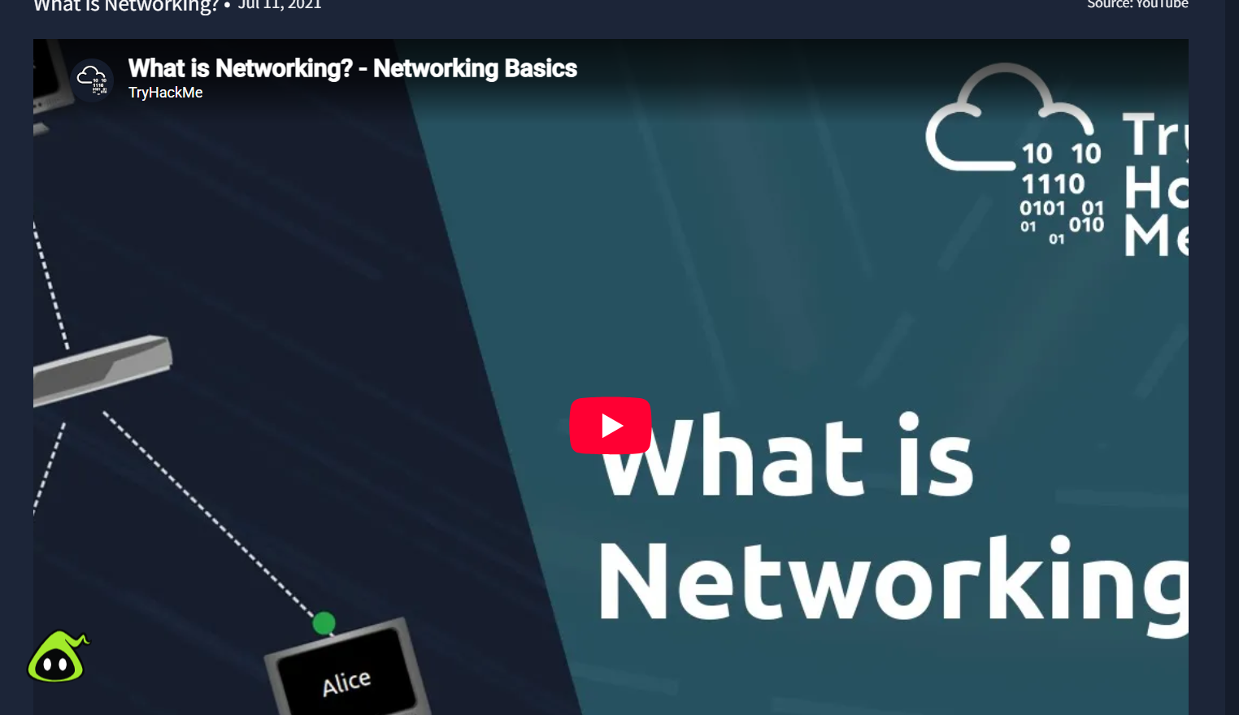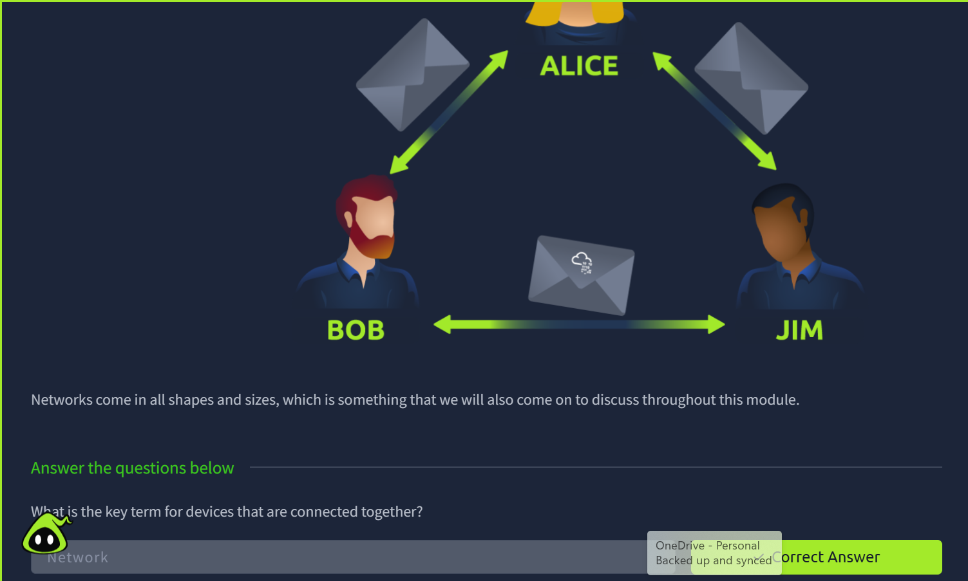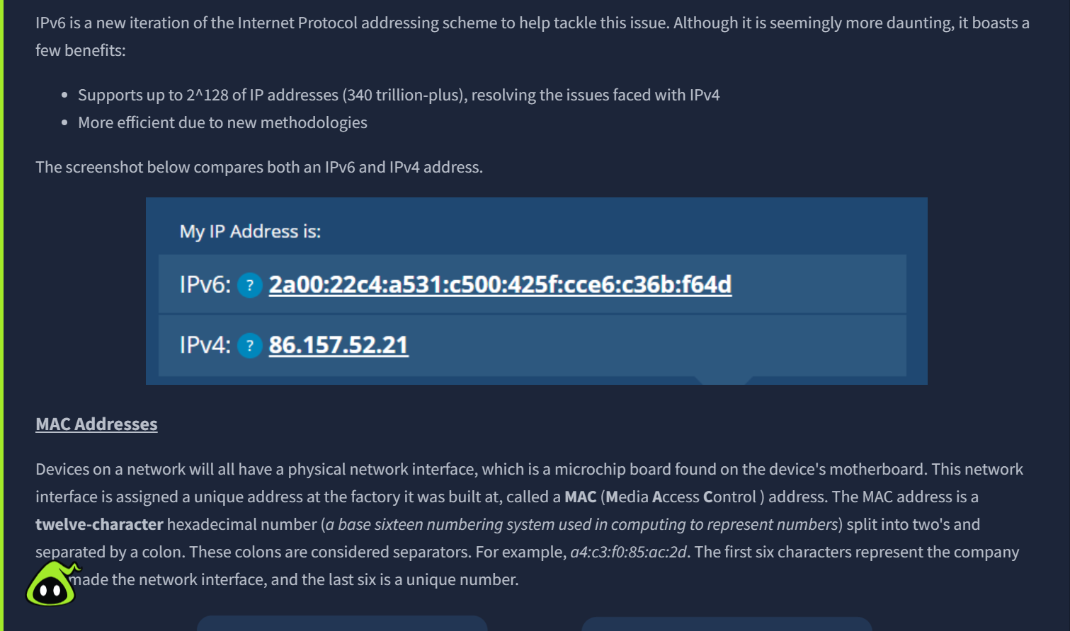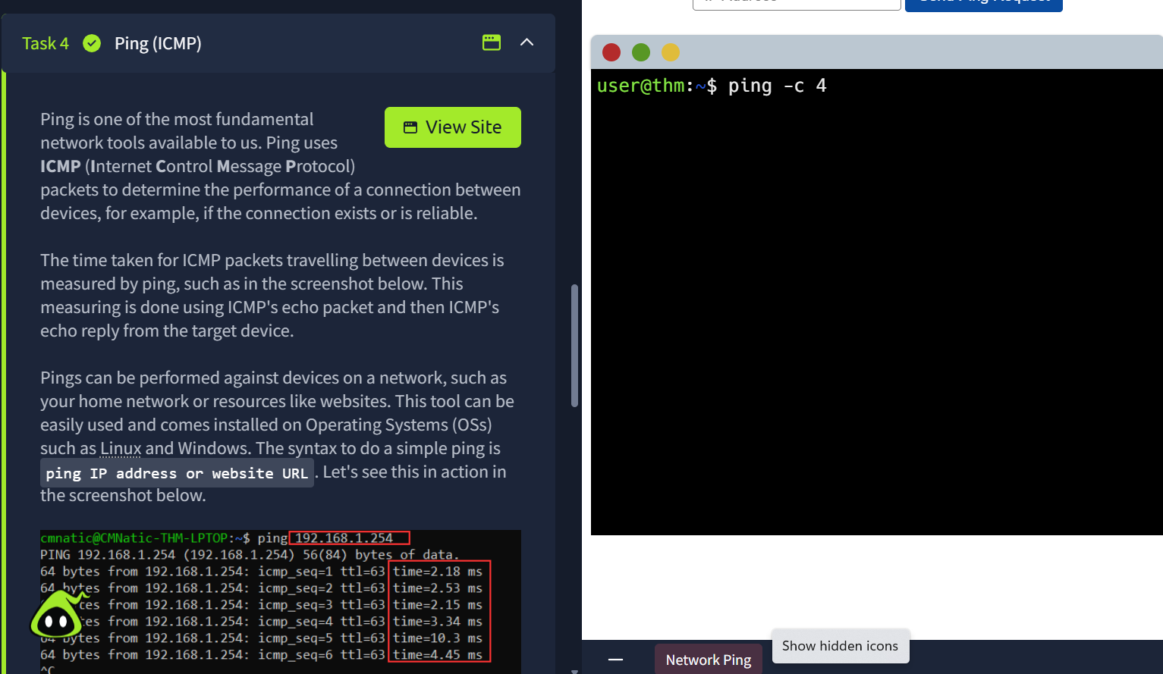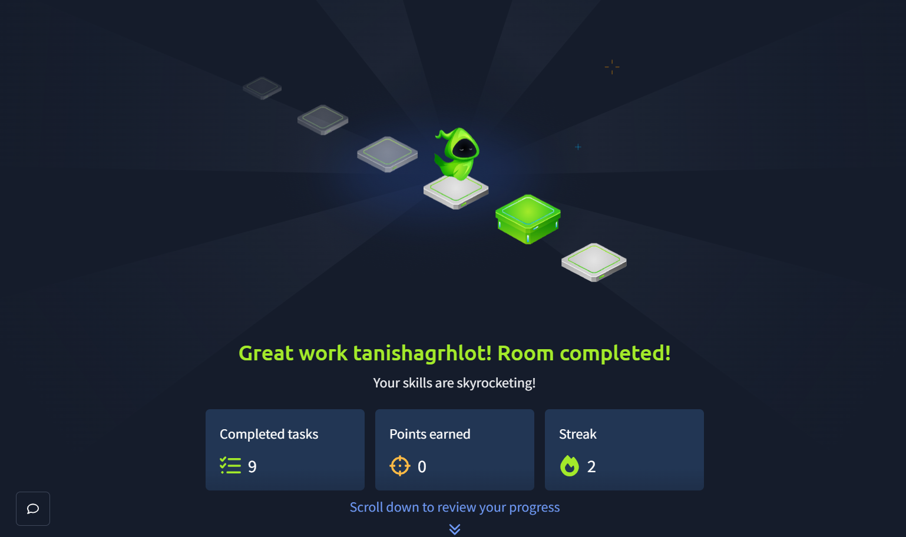

Room 2 screenshots:
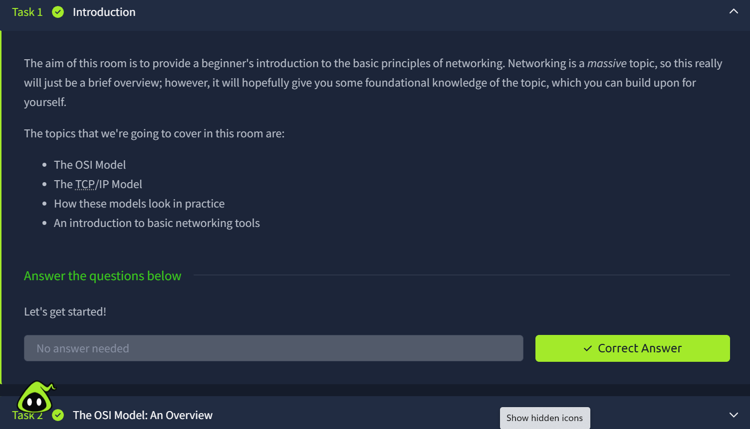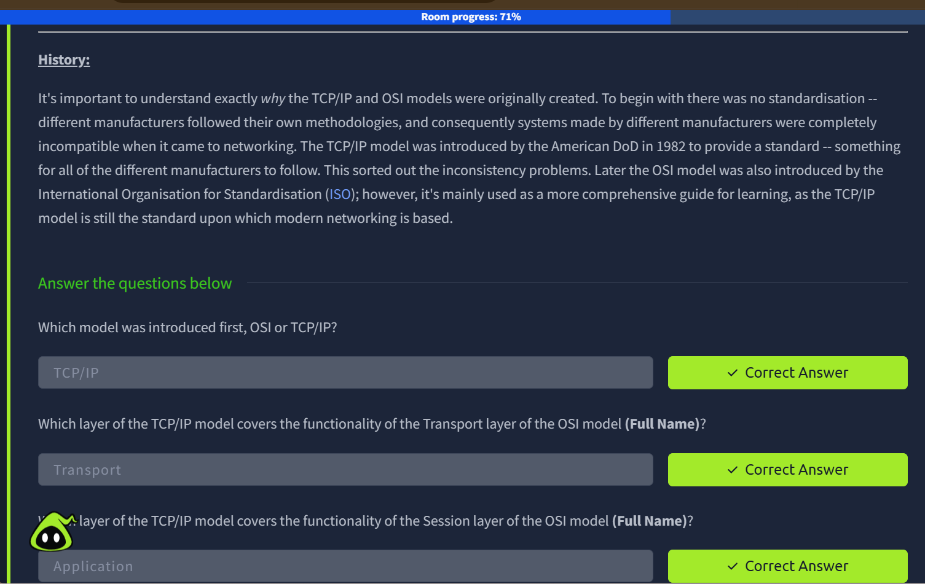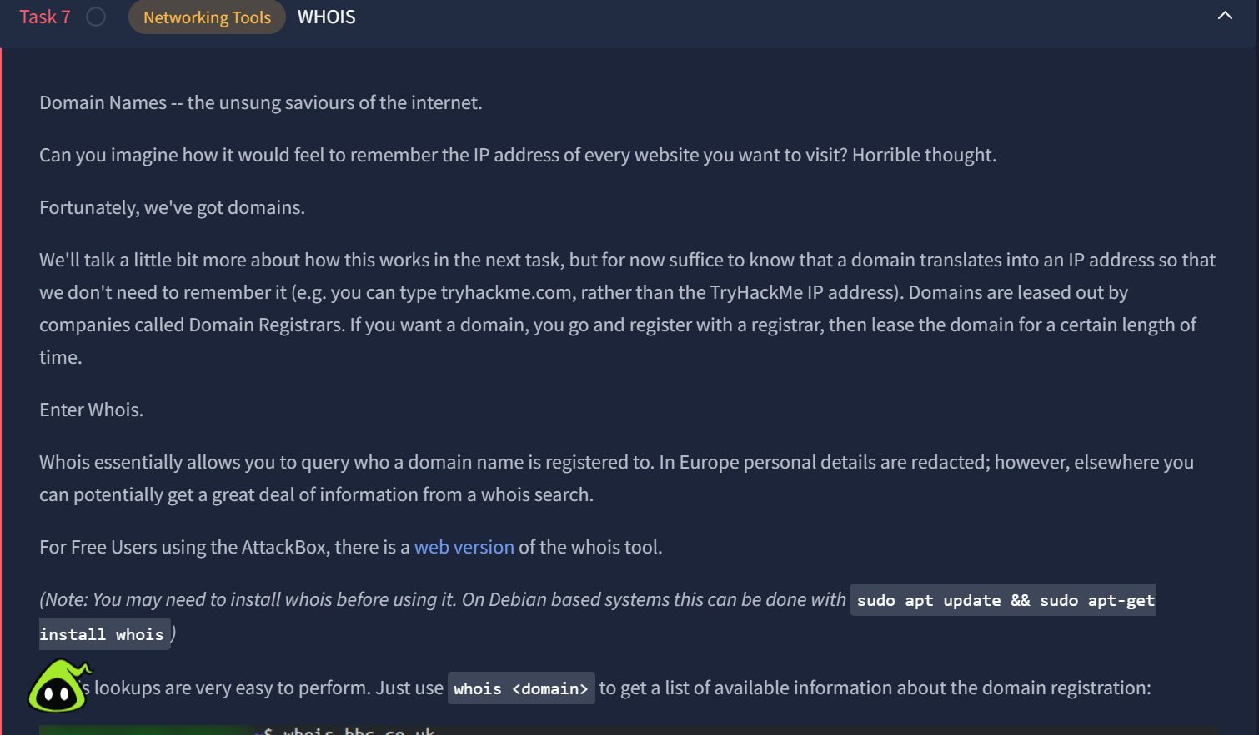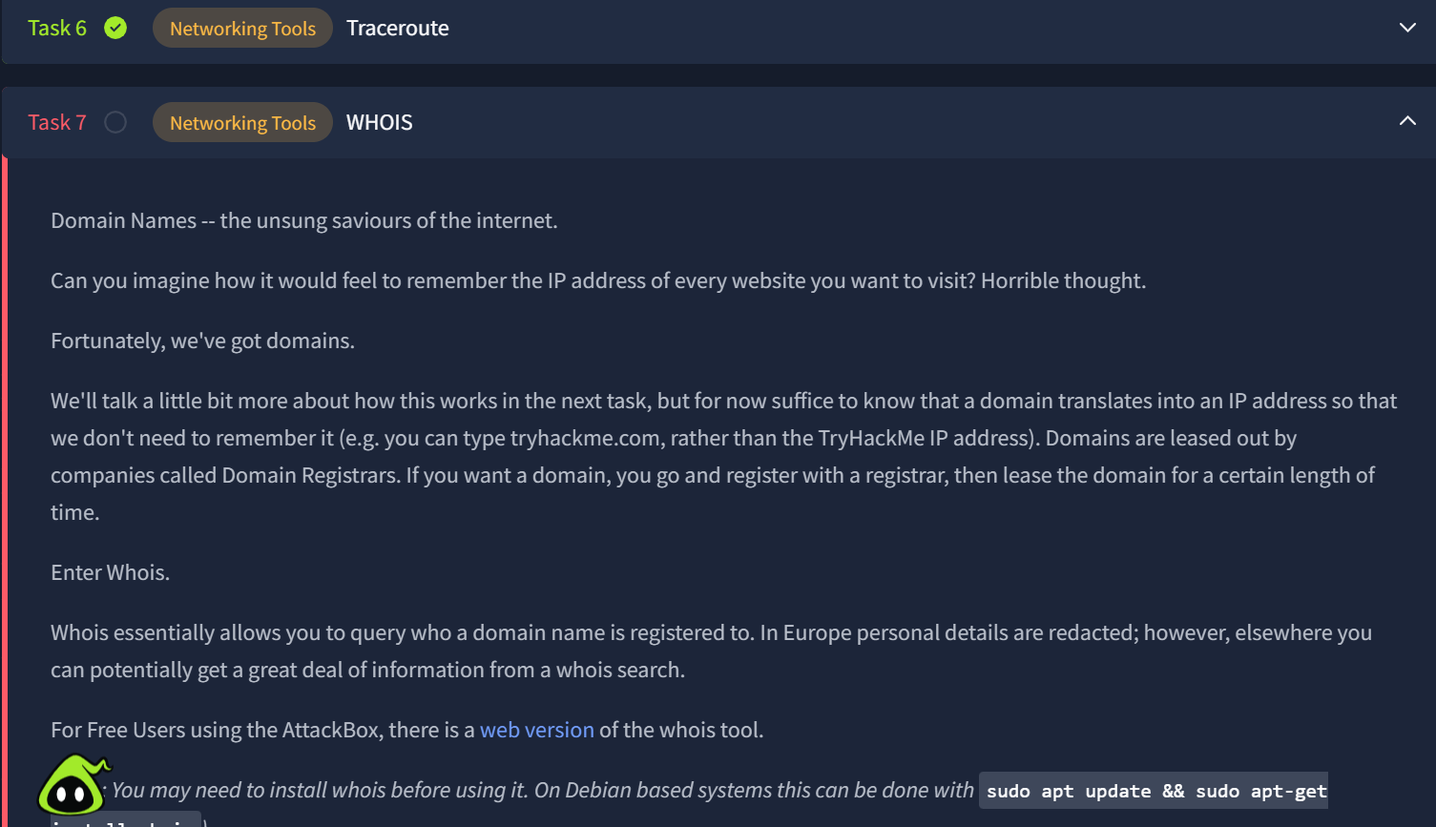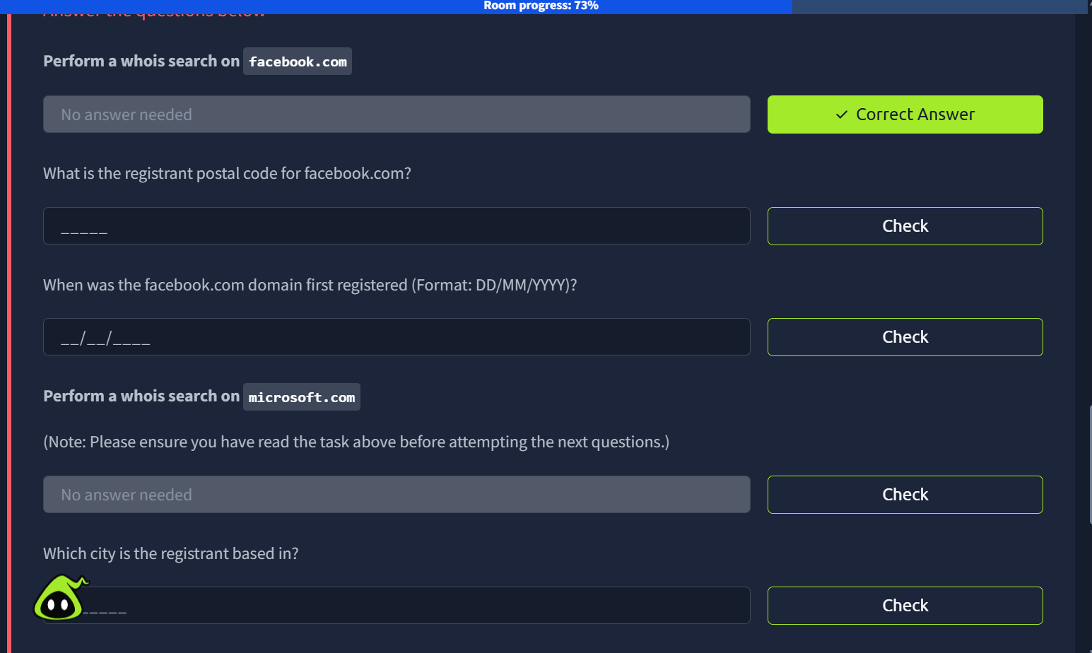

https://tryhackme.com/p/tanishagrhlot

